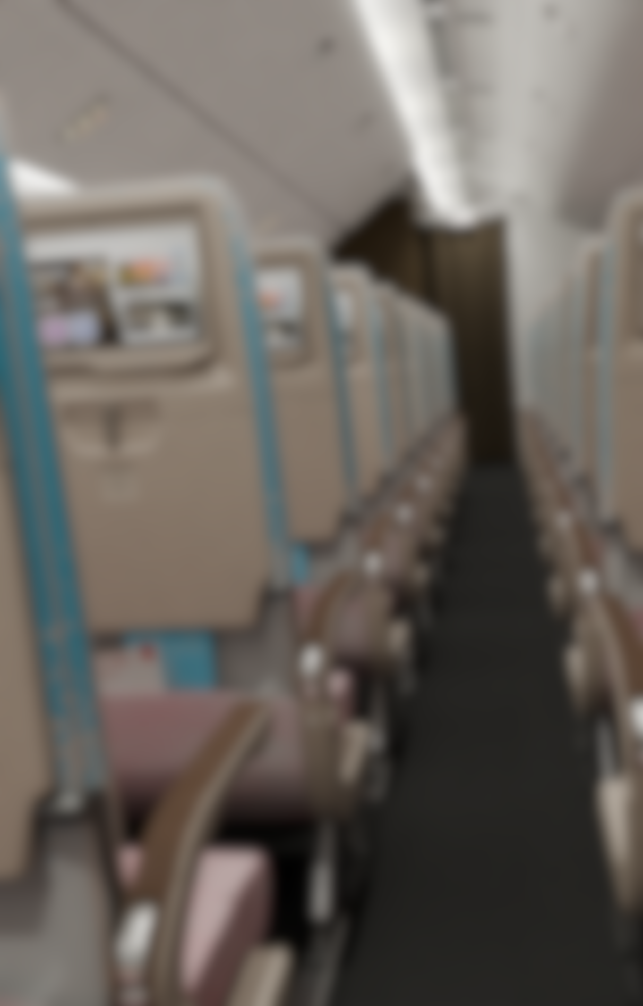

# **An Integrated Product Visualisation and Ticketing System**

Written Reflection by Cameron Carlyon

# Abstract

Renowned for its rapid pace of innovation, the airline industry is continuously embracing new technologies to enhance efficiency and maximise revenue streams. This paper aims to explore the impact of product visualisation directly within an airline booking web application.

Incorporating numerous points of reference such as industrial insights as well as a combination of primary and secondary surveys, this academic study was able to demonstrate that through the implementation of product visualisation within the booking process, potential customers are somewhat more likely to engage with upselling and cross selling in its current format, whilst significantly increasing overall customer satisfaction and retention levels.

# Acknowledgements

I would like to take this opportunity to acknowledge those that have helped me undertake this project.

First of all, I would like to thank my supervisor Andy Fitzpatrick for the valuable processes and techniques that I have learned from him over the academic year. Modular environment workflows were critical in the timely delivery of this project.

Subject tutors Anna Gardener and Jack Wood were also of immense support over the duration of this project and academic paper, having taken the time to go over details on numerous occasions and providing a solid understanding of the project over the course of the year.

Finally, I would like to extend my gratitude to my friends and family. Not only for their continuous input into my project, but also for their constant support over the past several years of my academics.

Table of Contents

An Integrated Product Visualisation and Ticketing System 0

Abstract 1

Acknowledgements 1

Table of Contents 1

Introduction 2

Contextual Review 2

Main Body 2

Analysis of Results 10

Conclusion 12

Bibliography 13

Appendix 14

# Introduction

An exceptionally dynamic environment, the airline industry is one that is constantly seeking to embrace emerging technologies so as to enhance operational efficiency and customer satisfaction. Despite the numerous advances in online airline booking systems over several decades, these advancements within conventional booking systems often fall short with regard to providing an accurate and informative user experience, particularly in the area of seat selection.

The ability to visualise seating arrangements accurately is postulated to be of great convenience for customers, as it directly impacts their comfort and overall travel experience. Despite this, traditional airline booking systems are limited to two-dimensional seating maps which provide limited information to the customer, often leading to dissatisfaction when actual seating conditions do not meet expectations such as windowless outboard seats and emergency exit rows with limited visibility externally (Walton, 2020).

This academic paper will detail the processes undertaken to craft a solution to this concern, utilising a collection of comprehensive literature and industry standard practices and demonstrate the potential in product visualisation within an airline booking system for improved rates of customer satisfaction and customer retention as well as increased revenue through upselling and cross-selling.

# Contextual Review

*This section of the academic paper may be found within the relevant document.*

# Main Body

Having established a foundational review of existing literature relevant to the subject of product visualisation and booking portals, the following section provides an in-depth overview into the core practical investigation and execution of the major project which hopes to further explore the prior research questions and objectives, being what impact product visualisation within an airline booking system could have on upselling, cross-selling as well as customer satisfaction and retention levels.

This project was structured in three key stages, those being design and development, implementation and user testing. Each phase of development was employed to ensure a release candidate that fulfilled user requirements and expectations with regard to functionality, usability and practicality.

Initial design and development planning began with the identification of the key requirements for the project at large. Researching existing product visualisation solutions on the market proved to be highly informative with regard to accumulating a set criterion for its practical execution. 3D Digital Venue provided a solid basis for the standards expected from consumers which claims to craft ‘exact replicas’ of sporting venues (3D Digital Venue, 2023). Successfully adapting this approach to stadia visualisation and event ticketing to the airline industry will be critical in the successful execution of this project’s goals.

So as to begin building a general overview of public attitude as well as to gather relevant information related to the development of the project, I first conducted a pre-development questionnaire to gather quantitative data which covered a number of topics pertaining to user opinions of typical airline booking systems. In doing so, I was able to discern a number of critical points of view with regard to the fundamental requirements and expectations of the end user.

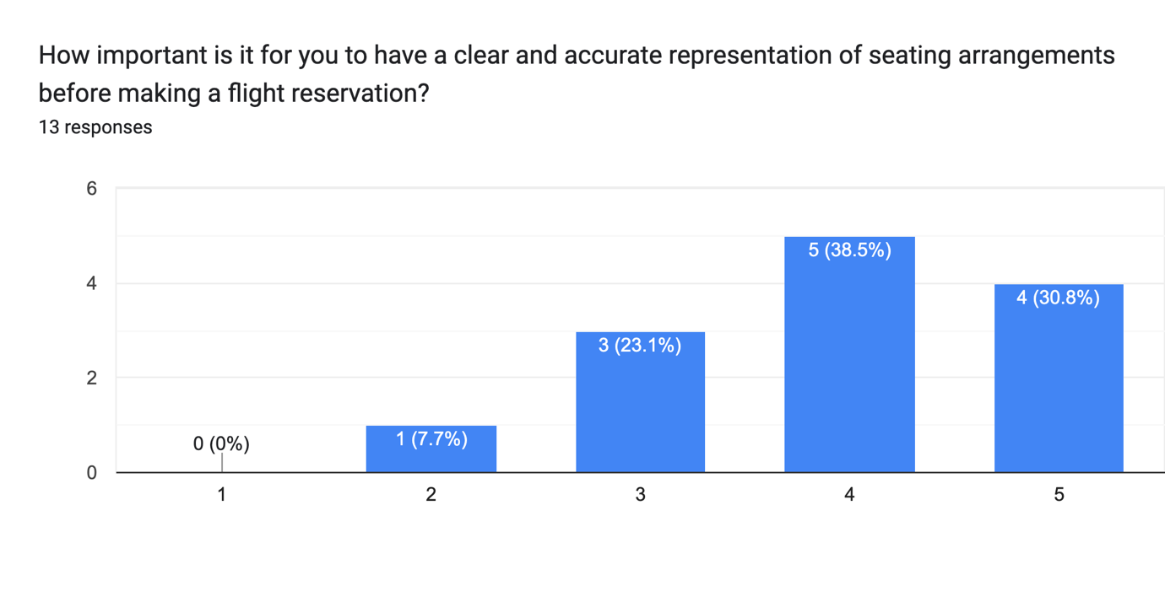

Figure 1 A chart representing user responses to the Pre-Production Questionnaire.

The above graph demonstrates that the majority of respondents found reasonable importance for clear and accurate representation of seating arrangements before making their flight reservation. As such, end users may find a prominent product visualisation portal more convenient and accessible than concealing it behind a supplementary menu system. A split screen interface featuring a traditional seating chart on the right-hand side, with an accompanying visualisation portal on the left-hand side would be the best resolution to this concern.

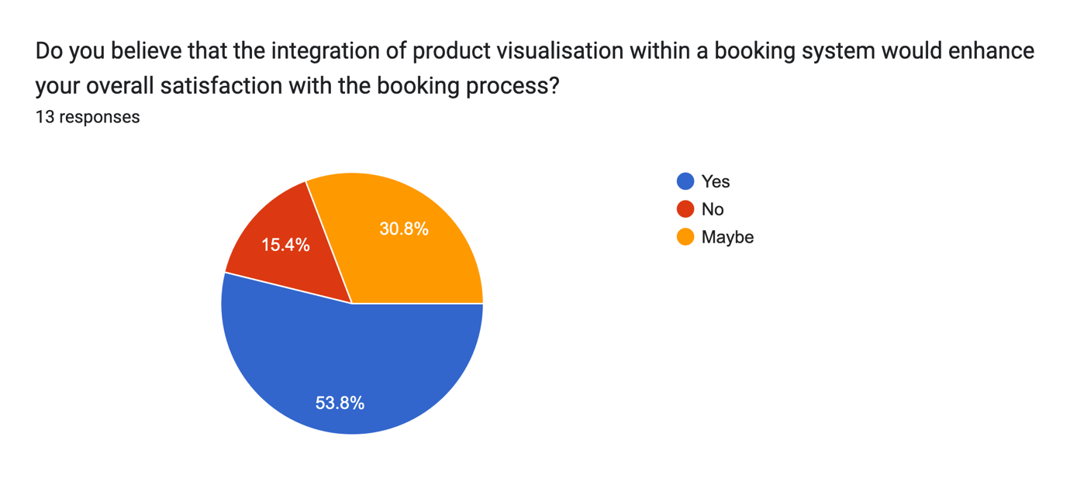

Figure 2A chart representing user responses to the Pre-Production Questionnaire.

With 53.8% of respondents answering “yes” and 30.8% of respondents saying “maybe”, this chart signifies that the integration of product visualisation would very likely enhance levels of customer satisfaction throughout the booking process for the majority of respondents, from a theoretical point of view. The challenge in this methodology is uncovering a suitable approach that does not take away from the user experience, but rather supplementing the functionality that already exists and building upon it.

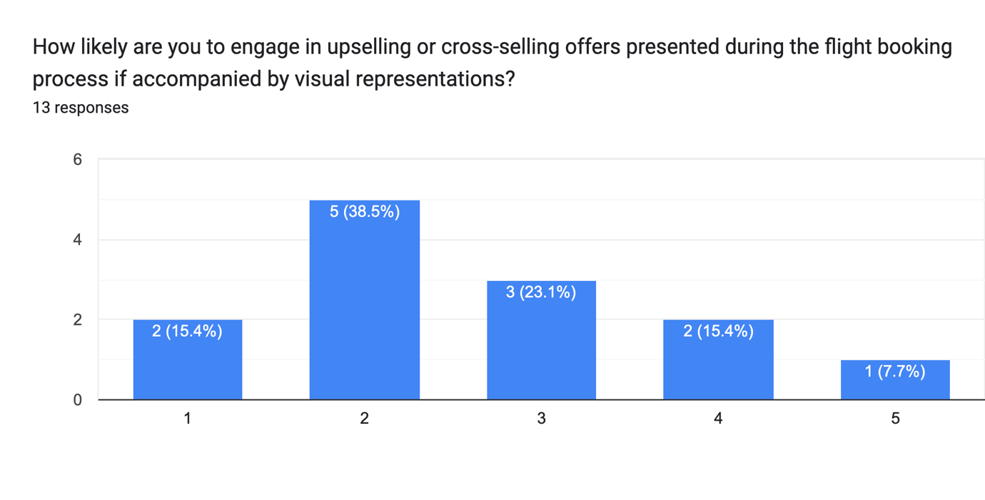

Figure 3 A chart representing user responses to the Pre-Production Questionnaire.

With the previous points in mind, the above graph contradicts the project’s hypothesis of product visualisation increasing levels of upselling and cross-selling given that a significant 38.5% of respondents claimed that they were unlikely to engage with upselling and cross-selling presented during the booking process. As such, I elected to conduct further investigation into the subject.

Hosting the product visualisation, the seamless execution of the web application was critical in drawing conclusions based on the project hypothesis. There were a number of core web development principles that were necessary to correctly execute such as responsive design for seamless usage across a wide variety of devices such as desktop computers, laptops, phones and tablets. This was to be executed through a Cascading Style Sheet technique called Responsive Design, in which web content may dynamically change the layout and structure to best suit the viewport in use (W3Schools, 2024).

Deliberating the implementation of the product visualisation within the web application, there were a number of considerations to be made with regard to performance, loading times and visual fidelity. Given the representative and broad nature of the project, it was necessary to produce an environment that came across as realistic as possible whilst remaining highly performant across a wide variety of devices. As such, a pre-rendered photosphere made the most sense rather than rendering the cabin on the users own device.

Utilising this approach, it is possible to produce highly detailed assets and lighting conditions whilst maintaining performance and interactivity. In order to facilitate this method of delivery, research was conducted into various JavaScript libraries that would display interactive 360-degree panoramic images within a web browser based upon an equirectangular panorama render (Blender Foundation, 2024). After a period of deliberation, the Photo Sphere Viewer JavaScript library was selected due to its high levels of configurability and mobile support (Sorel, n.d.).

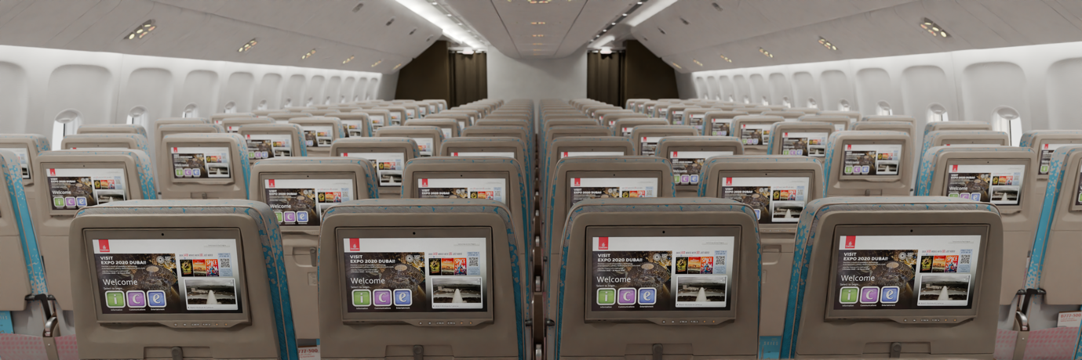

Figure 4 A promotional overview of the mid-economy section.

The development of this product visualisation project was a multi-step process, involving the implementation of web development and modular environmental modelling skillsets. As such, it proved critical to build a solid framework and foundation to build upon. The process began with the gathering of accurate and representative reference material. The precise scaling and proportions of the cabin were dependent on this reference material in the early stages of the project, therefor the requirement for high quality material from reputable sources was imperative. A basic block out was produced so as to ensure accurate asset sizes and proportions throughout the cabin. The lighting, environment modelling and material creation were all carried out using the open-source modelling software Blender and the various advanced tools that it provides such as assets, files, data systems, modifiers and physics simulations (Blender Foundation, 2024) to name just a few.

The utilisation of the Subdivision Surface modifier was critical throughout the development of this project. It works by multiplying poly surfaces and averaging their locations (Blender Foundation, 2024). This allows the user to develop incredibly high-poly meshes through low-poly modelling. Not only did the utilisation of Subdivision Surface modifiers simplify the modelling process, but it also ensured an optimal level of performance within the viewport. This made the development of highly detailed, modular environments far easier to work with.

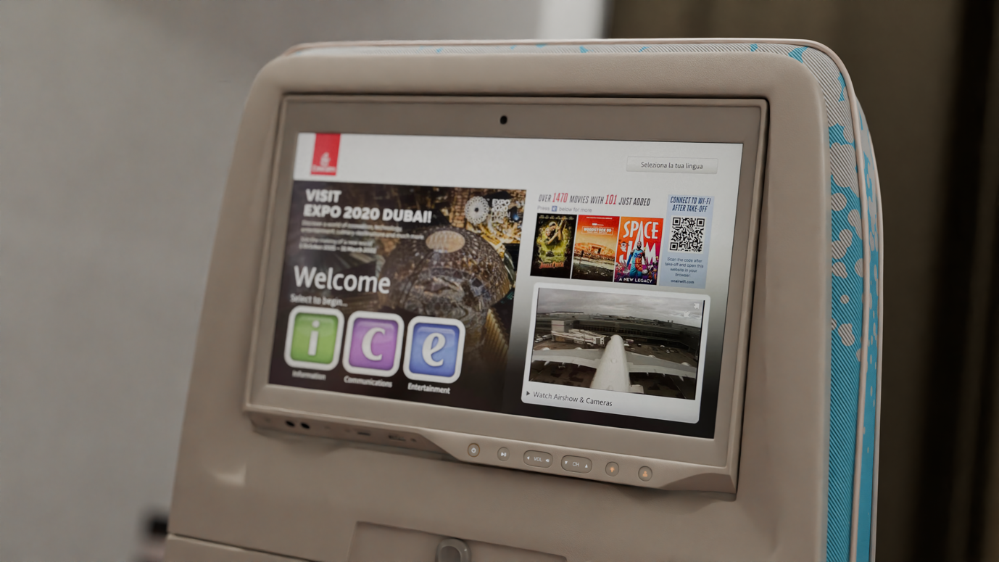

Figure 5 A promotional shot of an economy In-Flight Entertainment display.

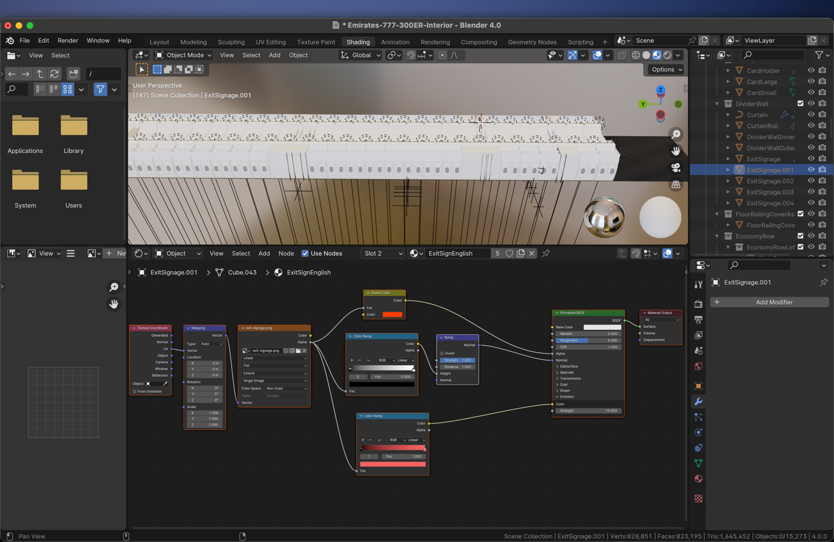The development of procedural materials played a critical role in the creation of a larger realistic environment. This included separate materials throughout the cabin environment so as to provide a high level of visual variation whilst reusing, where applicable, so as to reduce development time and performance cost.

Figure 6 The material node setup of the emergency exit decal.

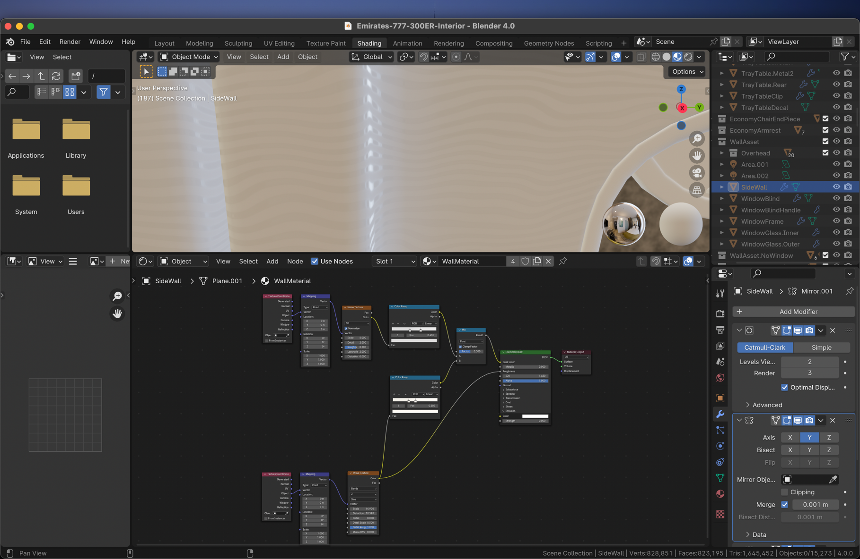The seat material needed to include not only a procedurally created base colour that emulated the one found upon its real-world counterpart, but also the fabric and the subtle variations in colour and roughness naturally found in the real world. These all needed to be fed into a bump map so as to provide an additional layer of visual fidelity. Similar methods of production can be found across all assets throughout the cabin such as the aircraft’s multi-layered windows which utilised shaders to produce correct reflectivity for dirt and smudges to add to the realism.

Figure 7 The material node setup of the cabin wall asset.

Whilst materials played a critical role in the overall visual style of the environment, not every single asset is compatible with this workflow. As such, a number of custom decals were crafted so as to fulfil this requirement and provide a sense of visual depth.

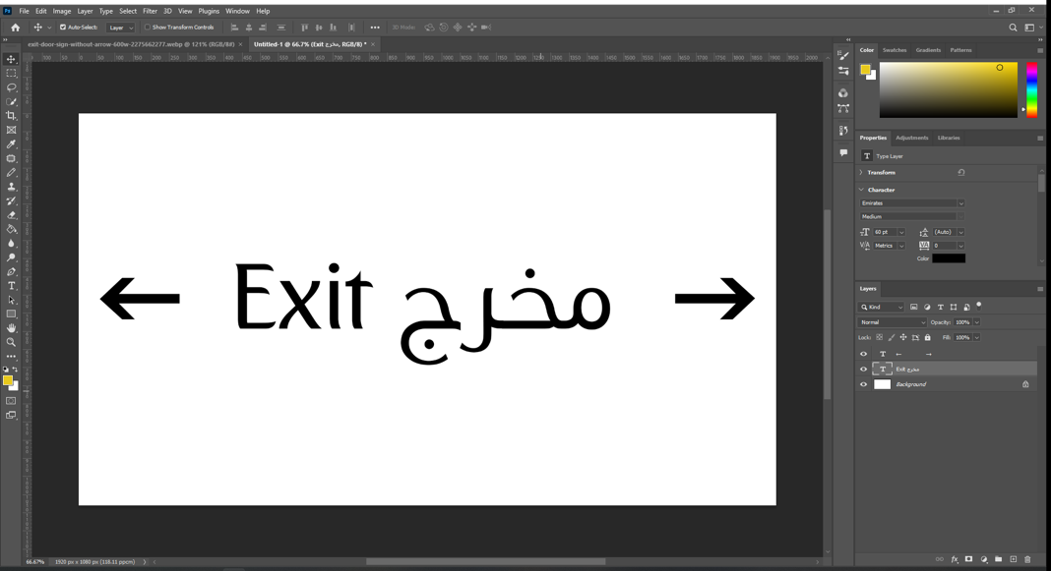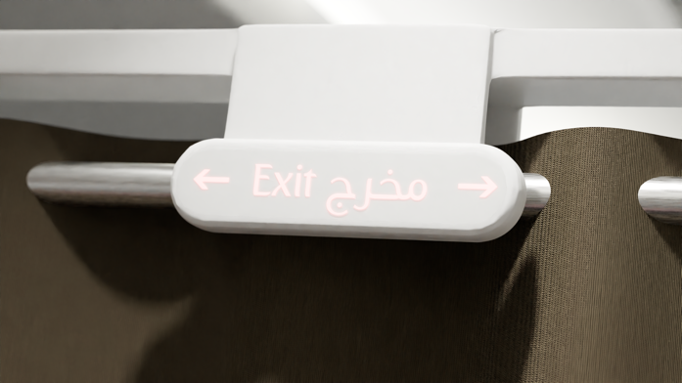

Figure 8 A production screenshot and promotional render of a decal found on the overhead of the interior cabin divider walls.

The above images demonstrate the detail that went into the various custom decals throughout the cabin. So as to provide an authentic aesthetic, real-world photography was used for reference material. Accurate replications of decals in both Arabic and English were produced within the industry standard software Adobe Photoshop, using the same proportions and fonts as their real-world counterparts. In this particular example of the emergency exit signage, the black and white colour values were fed into opacity and emission channels, with their corresponding values tweaked and adjusted accordingly.

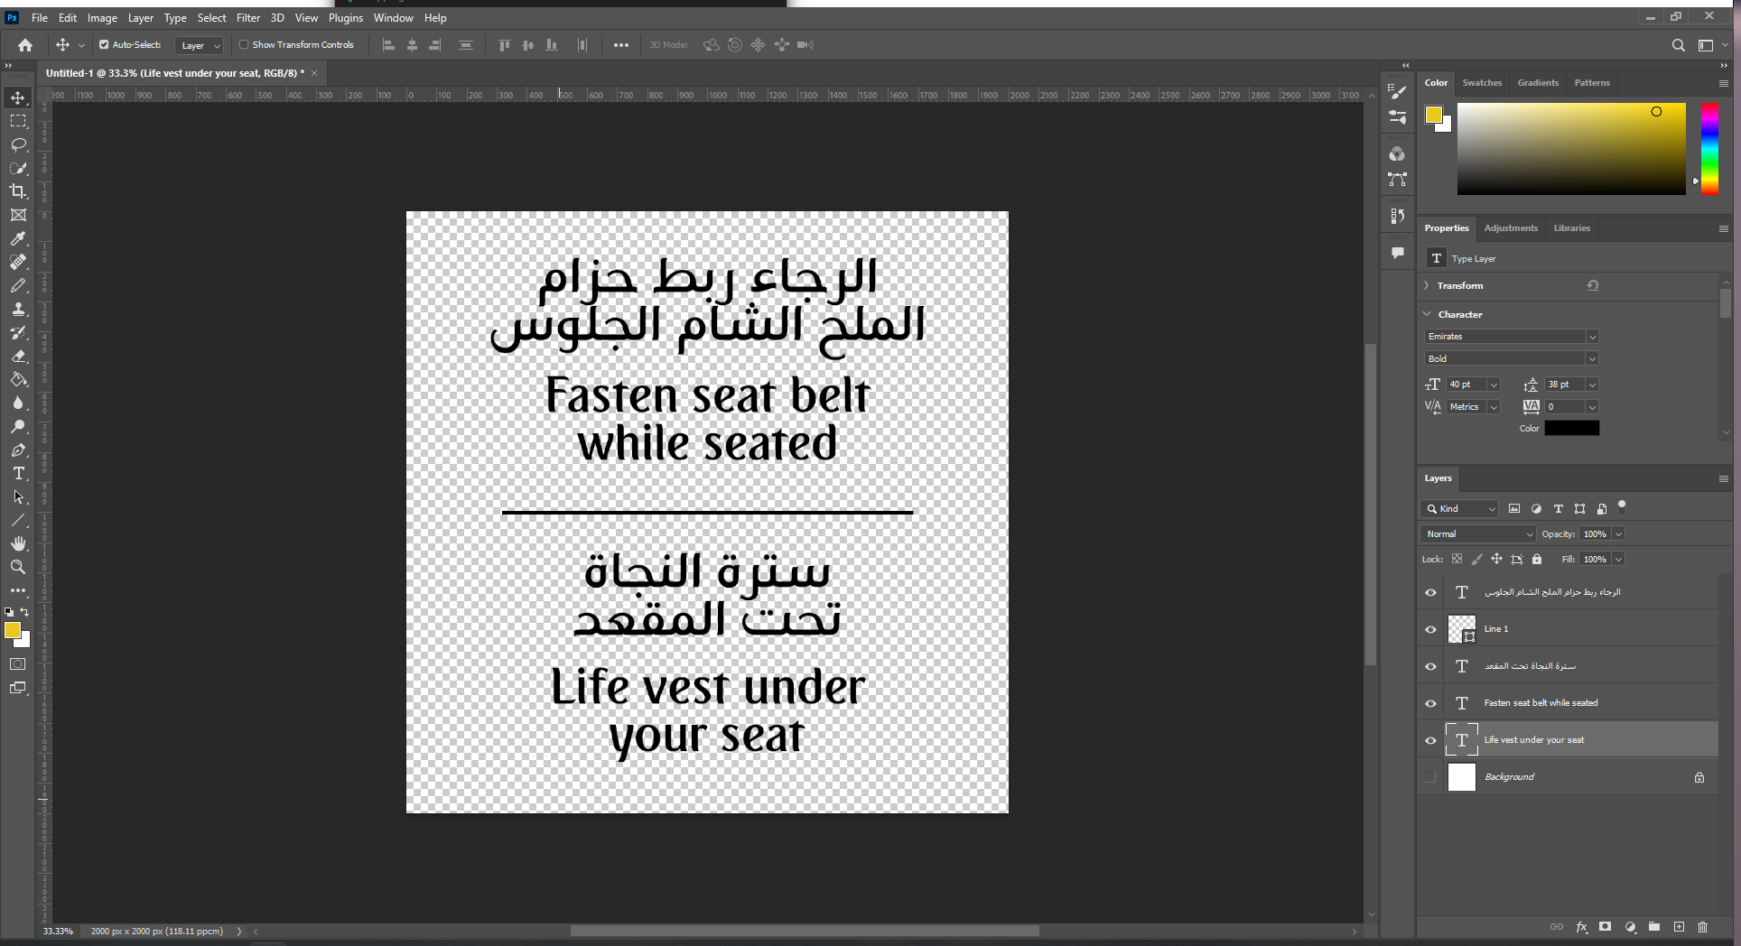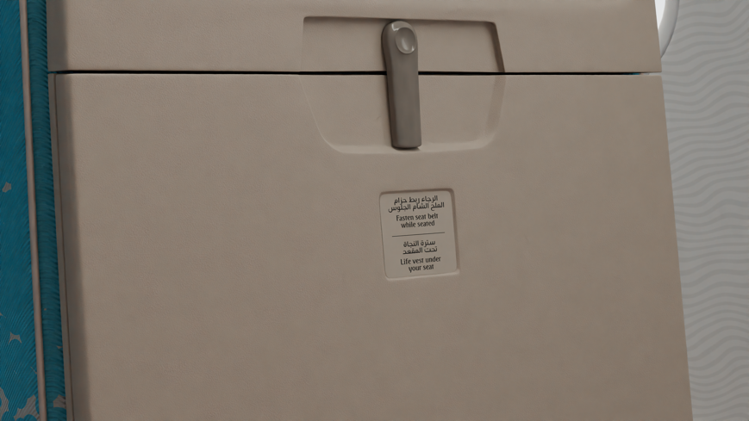

Figure 9 A production screenshot and promotional render of a decal found on a tray table.

Above is another example of the custom decals that may be found throughout the cabin environment. Similarly with the earlier example, this particular decal utilised a bump map channel so as to generate minuscule height adjustment on the lettering to provide the impression that it has been printed on. Such attention to detail goes a long way in providing an authentic visual experience for the end user.

Lighting elements throughout the scene, such as the adjustable overhead lights as well as the hidden accent lighting brought a tremendous amount of life to the scene, with close attention to detail being paid to the overall brightness and colour temperature based upon a sizable collection of reference material. A high resolution CC0 licensed HDRI (High Dynamic Range Image) (Kai Hegeler, n.d.) world environment texture was used to provide external lighting and the general appearance of the skybox outside of the aircraft. The goal with regard to HDRI selection was to produce a light and airy environment that came across as clean and spacious to the end user.

Whilst the development of the project was underway, a production questionnaire was published so as to gather a fresh perspective on the project as a whole. When queried of the overall quality of assets and materials, respondents reacted positively to these factors, albeit with a limited quantity of responses.

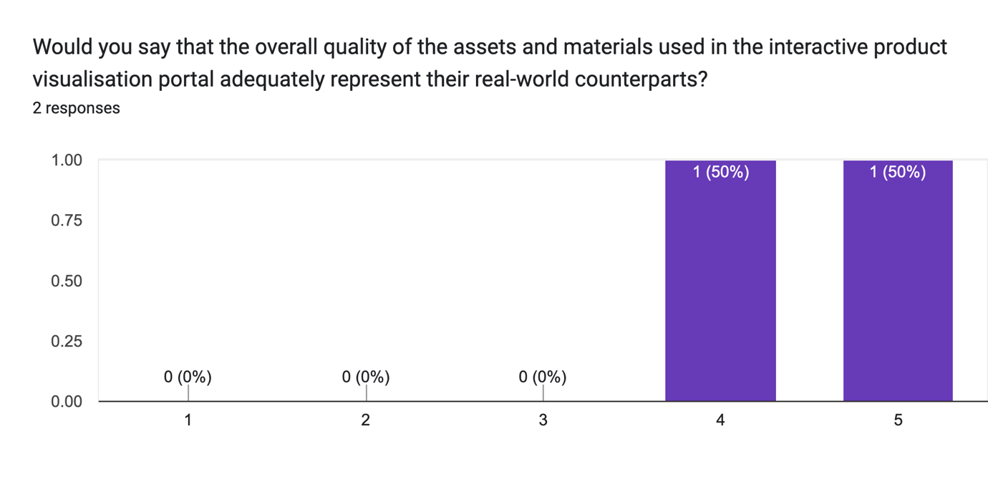

Figure 10 A chart representing user responses to the Production Questionnaire.

Given the representative nature of the project, it was compulsory that the cabin environment represented its real-world counterpart as accurately as possible. As such, highly reputable resources were utilised, such as SeatGuru, which detailed seating layouts and dimensions.

Whilst not the focus of this particular paper, a further amount of time and effort went into the development of the web application. Built using the industry standard languages of HTML, CSS and JavaScript, the preliminary design stage utilised Figma to craft an initial visual concept. This visual concept was then built within Microsoft Visual Studio Code using a mixture of HTML and CSS.

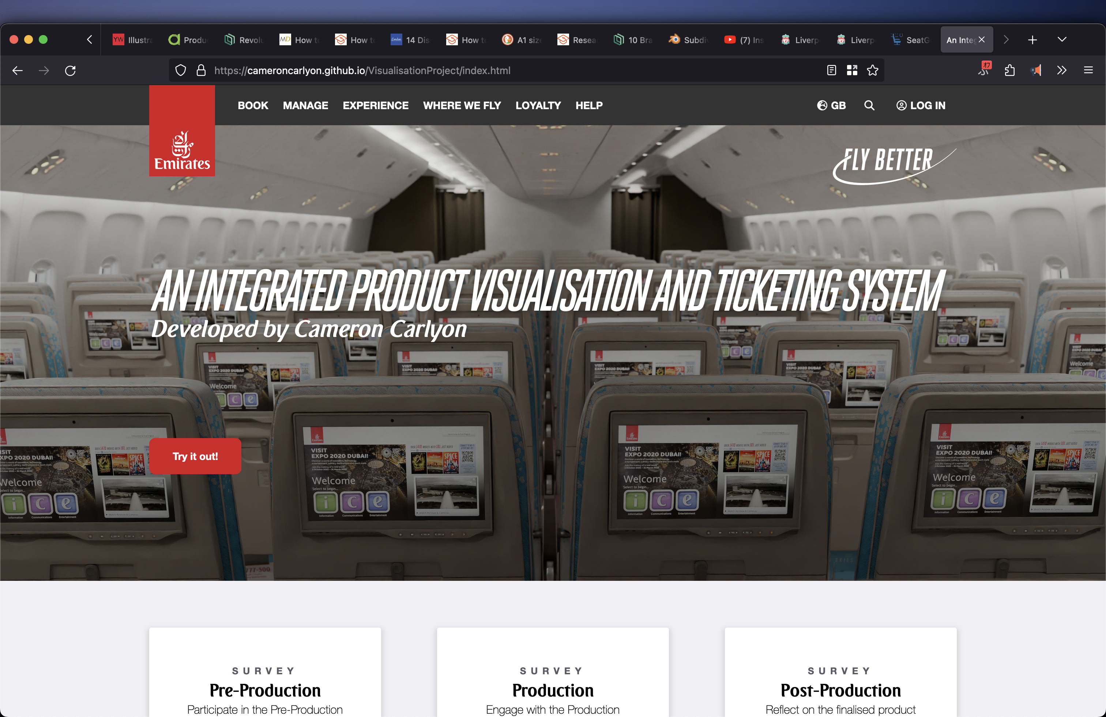

Figure 11 The landing page of the project web application.

Given the requirement to develop for mobile devices as well as desktop, it was critical to implement Responsive Design using industry standard techniques. In doing so, the web application may function across all devices with varying screen sizes (Mozilla Foundation, 2024). Functionality was later implemented using JavaScript. Such functionality included modals, contact forms and perhaps most importantly, the product visualisation swapping.

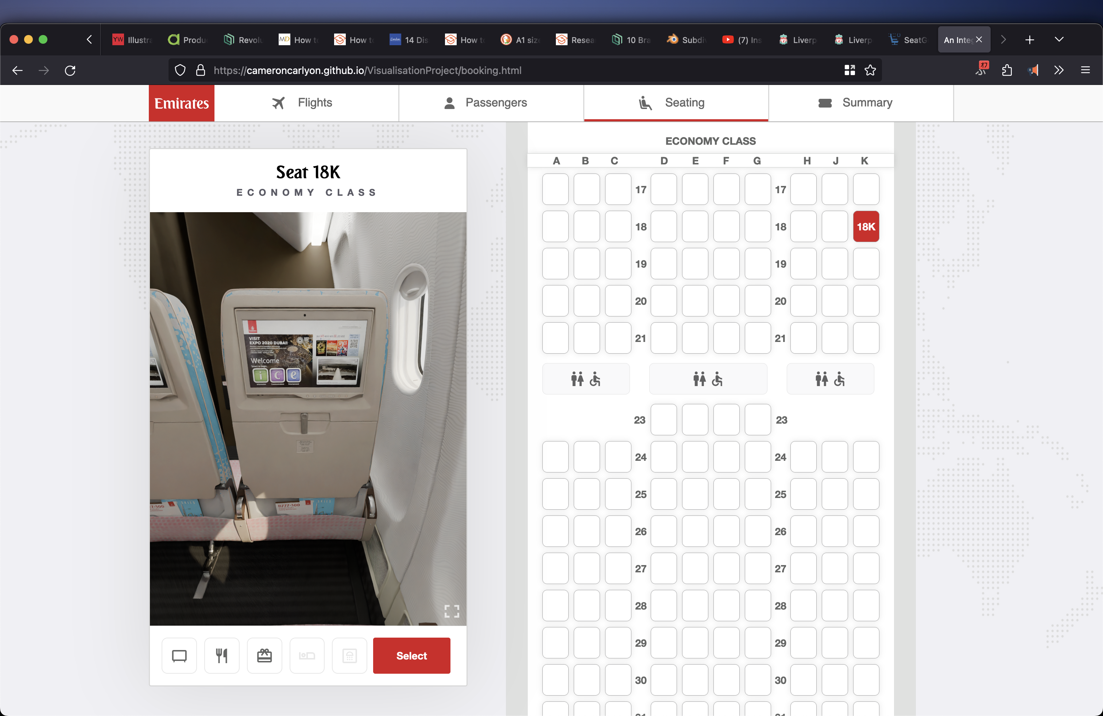

Figure 12 The booking page of the project web application.

# Analysis of Results

The implementation of product visualisation within an airline booking system was a striving project to undertake, thus relied upon constant user feedback to address shortcomings and limitations. This section analyses the outcomes of user testing and surveys conducted to evaluate the effectiveness of the release candidate. Upon publication of the final project, a post-production questionnaire was issued so as to gather both quantitative and qualitative data to develop an understanding of how the project has challenged the initial project hypothesis.

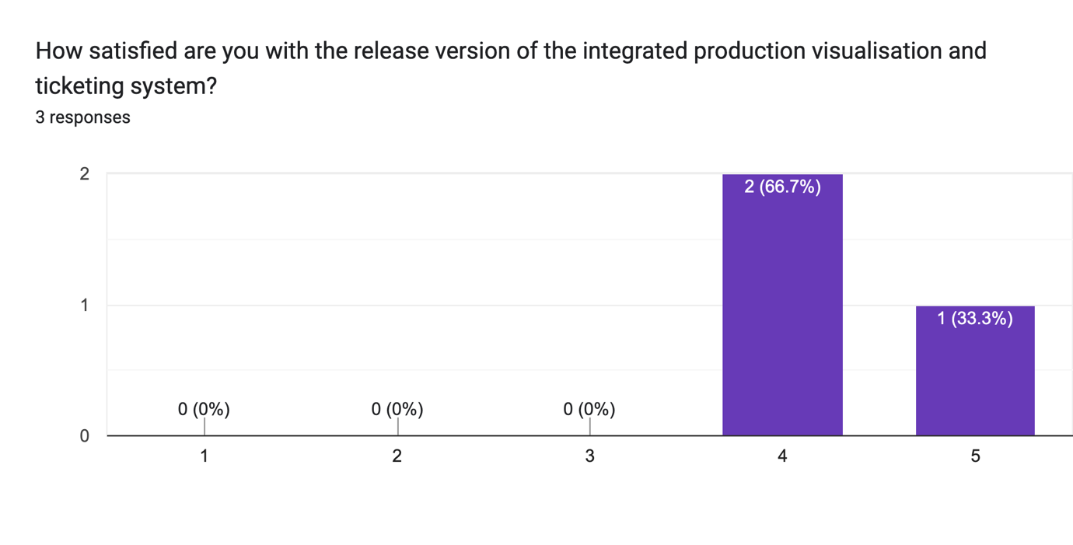

Figure 13 A chart representing user responses to the Post-Production Questionnaire.

So as to measure user satisfaction levels, respondents were asked to rate their experience with the product visualisation and booking system on a scale of one to five. The majority of participants rated their experience between four to five, indicating a high level of satisfaction with the final outcome.

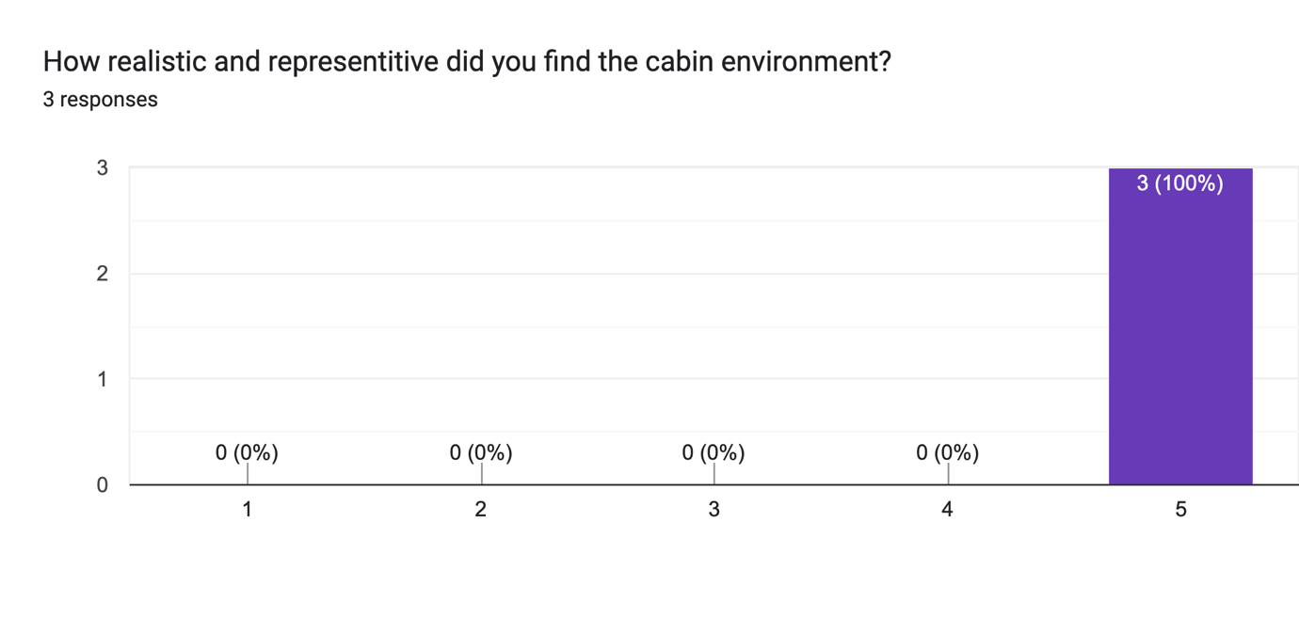

Figure 14 A chart representing user responses to the Post-Production Questionnaire.

The detailed cabin environment was particularly well-received, with all respondents providing a perfect score. This demonstrates that the procedural approach to material creation and high resolution meshes through the utilisation of the Subdivision Surface modifier were strong choices in this regard.

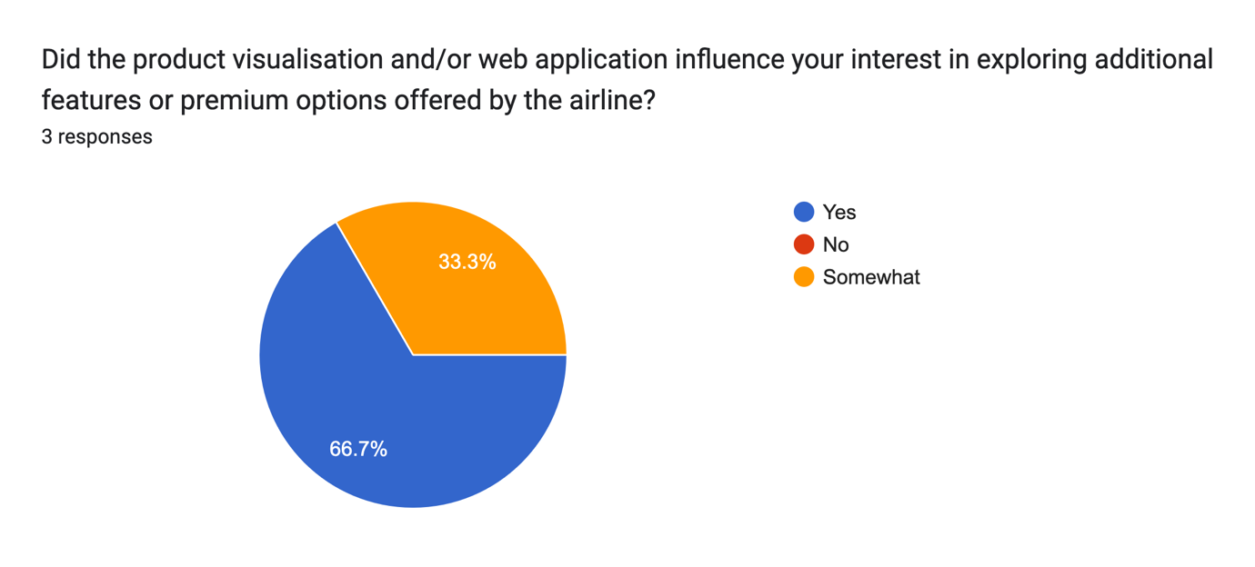

Figure 15 A chart representing user responses to the Post-Production Questionnaire.

Respondents were also queried about their reception to various upselling and cross-selling opportunities that were presented throughout the web application. This included lie-flat seating found in business class and onboard showers found in first class. With 66.7% of respondents expressing an interest in exploring premium features, it would not be unreasonable to conclude that this project’s conservative implementation of upselling and cross-selling has had a modest impact on users.

Further from this, the post-production questionnaire received a number of written responses:

* *“It was nice being able to [see] it and visualize the [seating]. Usually, you don’t have time for that, so it was a nice experience.”*
* *“Faster loading improvements to the visualisation portal.”*
* *“Aside from the slight technical page loading issue, it's extremely well made and detailed, I'd go as far as to say it's better than the original Emirates website. It's easy to navigate and the seating designs are amazing!”*

Given this combination of Quantitative and Qualitative feedback, it may be concluded that the project’s original postulation has been satiated to a reasonable mark.

# Conclusion

This academic project set out to explore the influence of product visualisation within an airline booking system, aiming to enhance customer satisfaction and retention as well as increasing engagement rates for upselling and cross-selling. Through the execution of a detailed methodology involving design, development, implementation as well as user testing and feedback, this academic study provided significant insights into the benefits and limitations of this innovative marriage of technologies.

User questionnaires were conducted throughout all development and planning stages of this project, which demonstrated that product visualisations within an airline booking system considerably improves user satisfaction levels by offering a more accurate representation of seating arrangements. Respondents expressed higher confidence in their seat selection given their detailed view of legroom, window location and overall cabin layout.

Undesirably, the impact of product visualisation on upselling and cross-selling rates was found to be modest, despite improving user experience overall. This suggests that whilst product visualisation can prove to be a valuable addition to an airline booking system, upselling and cross-selling may need to be part of a broader strategy that embraces comprehensive user engagement tactics and better captures the users’ consideration.

Since the initial planning stages of this project, usability, functionality and scalability across devices was at the forefront of intended specifications. Questionnaire respondents provided feedback that indicated a suitable level of functionality accompanied by an intuitive interface. With this in mind, the issue of visualisation responsiveness was raised which may be resolved using more aggressive compression techniques on each individual panorama file.

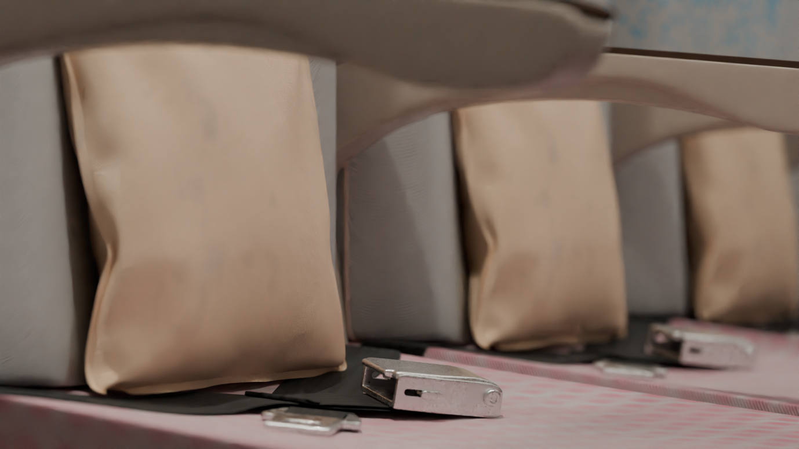

**Recommendations for Future Research and Practical Applications:**

1. **Performance Optimisations:** It is essential for a business to empower as many potential customers to use their service as possible. As such, continuous performance optimisations, such as more aggressive or dynamic compression techniques on seat panorama files, would prove to be highly beneficial in enabling a wide range of users and must be considered.
2. **Environment Variations:** Click spots may be utilised to enable the user to toggle between various cabin states such as time of day and tray table position, to name a few examples.
3. **Broader Implementation:** Expanding the employment of product visualisation beyond just seating locations and include other aspects such as in-flight services and amenities may further enhance customer engagement and confidence.

# Bibliography

3D Digital Venue, 2023. *Home | 3DDV.* [Online]   
Available at: https://3ddigitalvenue.com/  
[Accessed 13 11 2023].

Blender Foundation, 2024. *Blender 4.1 Manual.* [Online]   
Available at: https://docs.blender.org/manual/en/latest/index.html  
[Accessed 25 5 2024§].

Blender Foundation, 2024. *Cameras - Blender 4.1 Manual.* [Online]   
Available at: https://docs.blender.org/manual/en/latest/render/cycles/object_settings/cameras.html#equirectangular  
[Accessed 25 5 2024].

Blender Foundation, 2024. *Subdivision Surface Modifier.* [Online]   
Available at: https://docs.blender.org/manual/en/latest/modeling/modifiers/generate/subdivision_surface.html  
[Accessed 24 5 2024].

Kai Hegeler, R., n.d. *What is an HDRi Map? Detailed Explanation and Real-World Examples.* [Online]   
Available at: https://www.cgibackgrounds.com/blog/what-is-an-hdri  
[Accessed 25 5 2024].

Karki, M., n.d. *Airbus A380 Seat Map with Airline Configuration.* [Online]   
Available at: https://aviatechchannel.com/explore-airbus-a380-seat-map/  
[Accessed 16 11 2023].

Mozilla Foundation, 2024. *Responsive design.* [Online]   
Available at: https://developer.mozilla.org/en-US/docs/Learn/CSS/CSS_layout/Responsive_Design  
[Accessed 24 5 2024].

Sorel, D., n.d. *Getting Started | Photo Sphere Viewer.* [Online]   
Available at: https://photo-sphere-viewer.js.org/guide/  
[Accessed 25 5 2024].

Ticketing Business News, 2021. [Online]   
Available at: https://www.theticketingbusiness.com/2021/06/28/case-study-3d-digital-venue-and-zsc-lions-swiss-life-arena/  
[Accessed 19 11 2023].

W3Schools, 2024. *CSS Flexbox.* [Online]   
Available at: https://www.w3schools.com/css/css3_flexbox.asp  
[Accessed 25 5 2024].

Walton, J., 2020. *Avoiding the dreaded windowless window seat - Lonely Planet.* [Online]   
Available at: https://www.lonelyplanet.com/articles/why-does-my-window-seat-not-have-a-window-and-how-can-i-avoid-ending-up-there  
[Accessed 25 5 2024].

# Appendix

**Pre-Production Questionnaire**

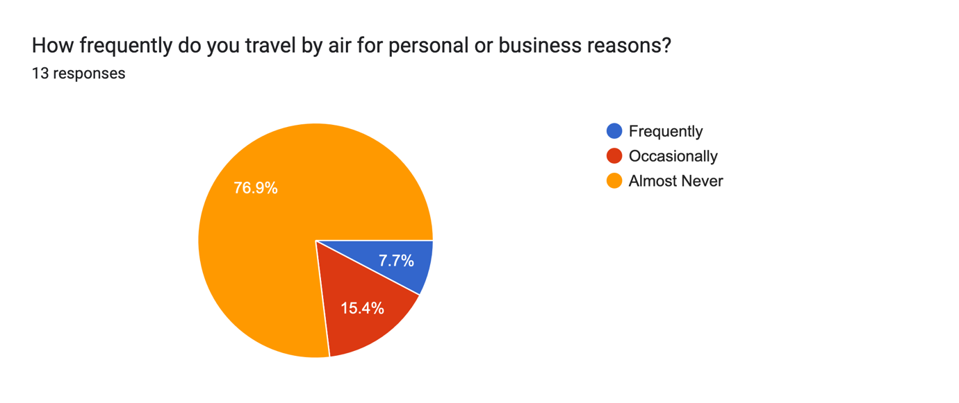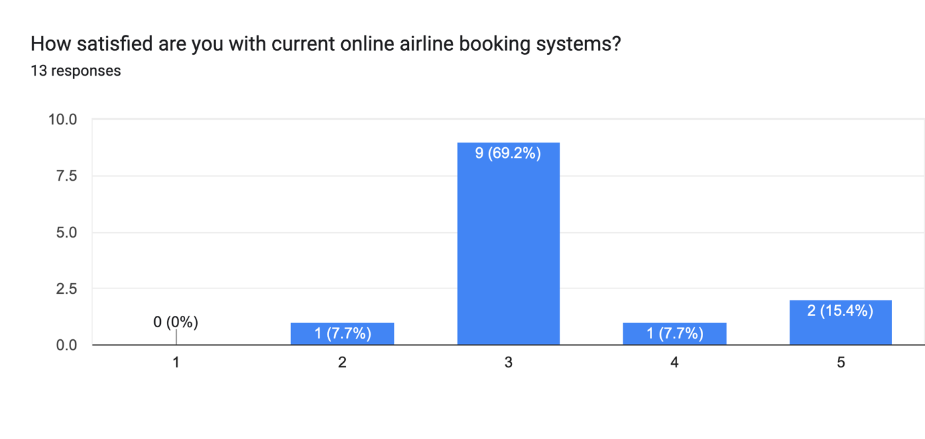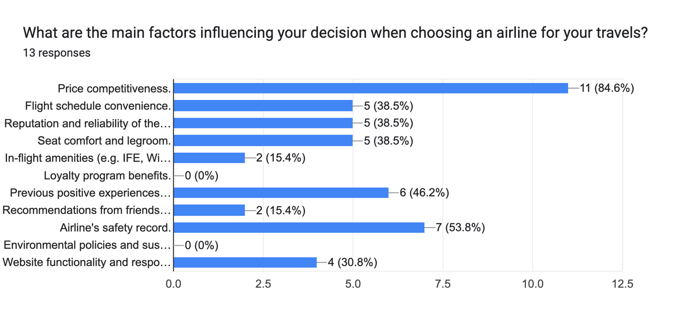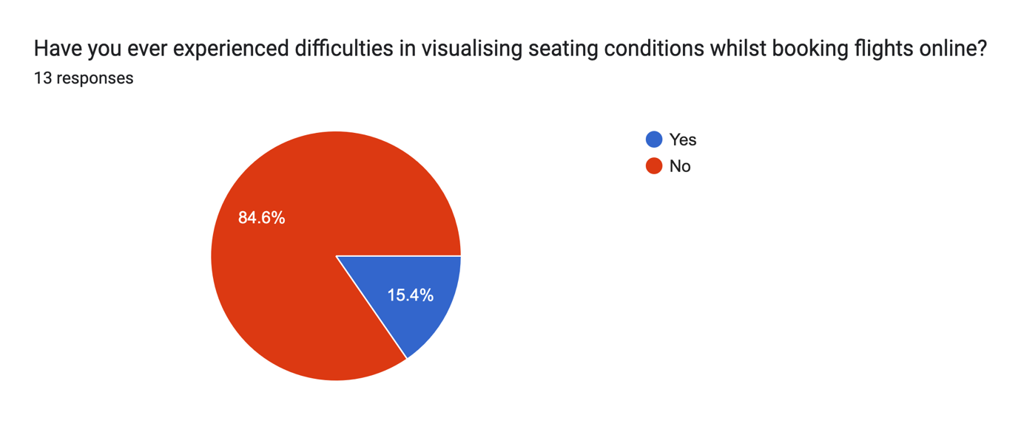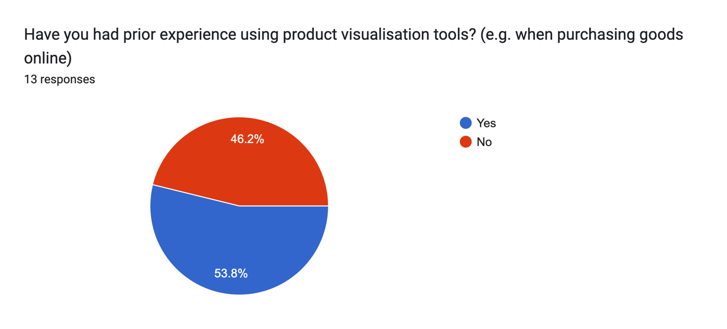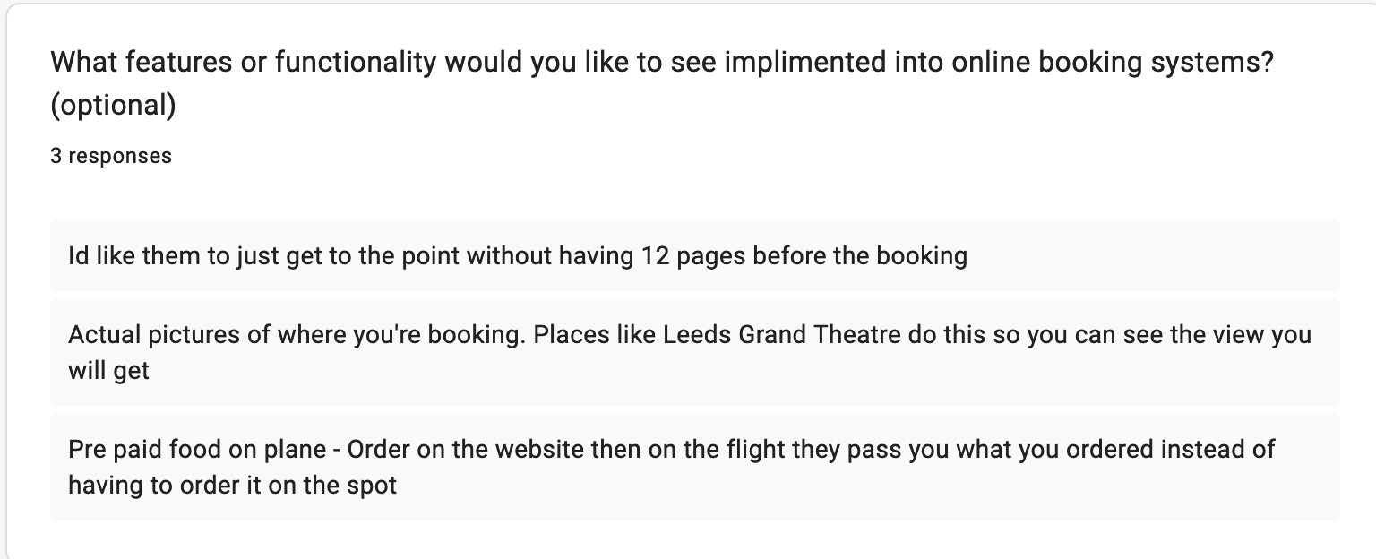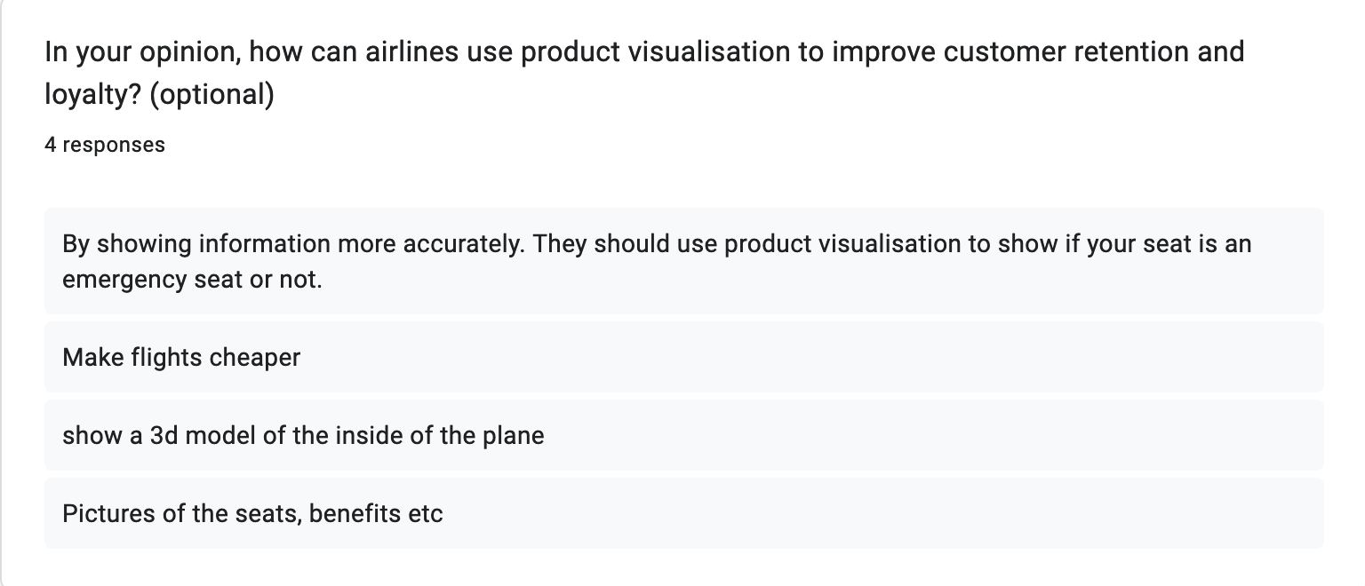

**Production Questionnaire:**

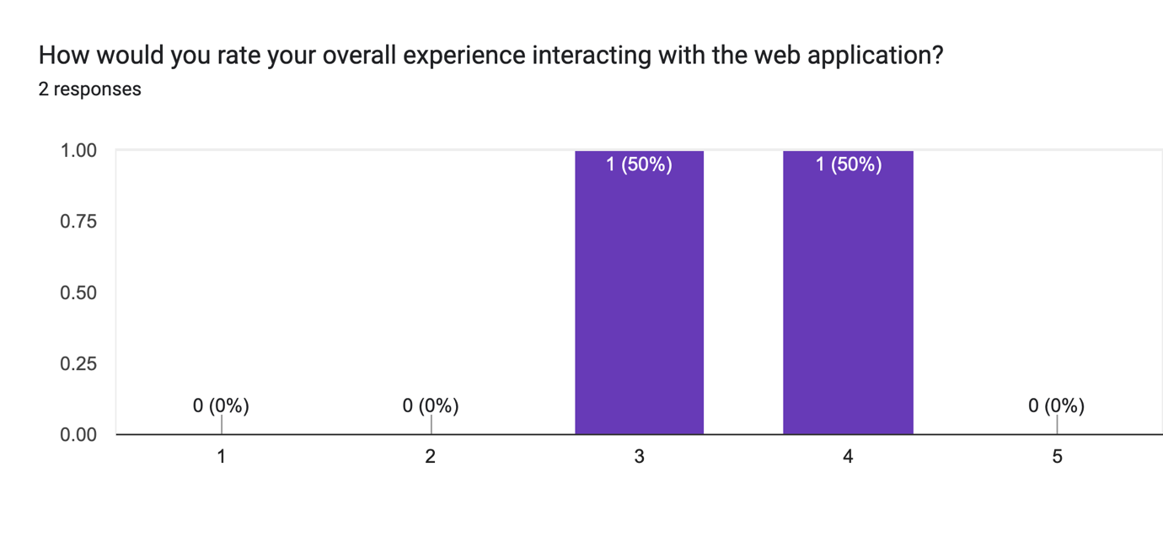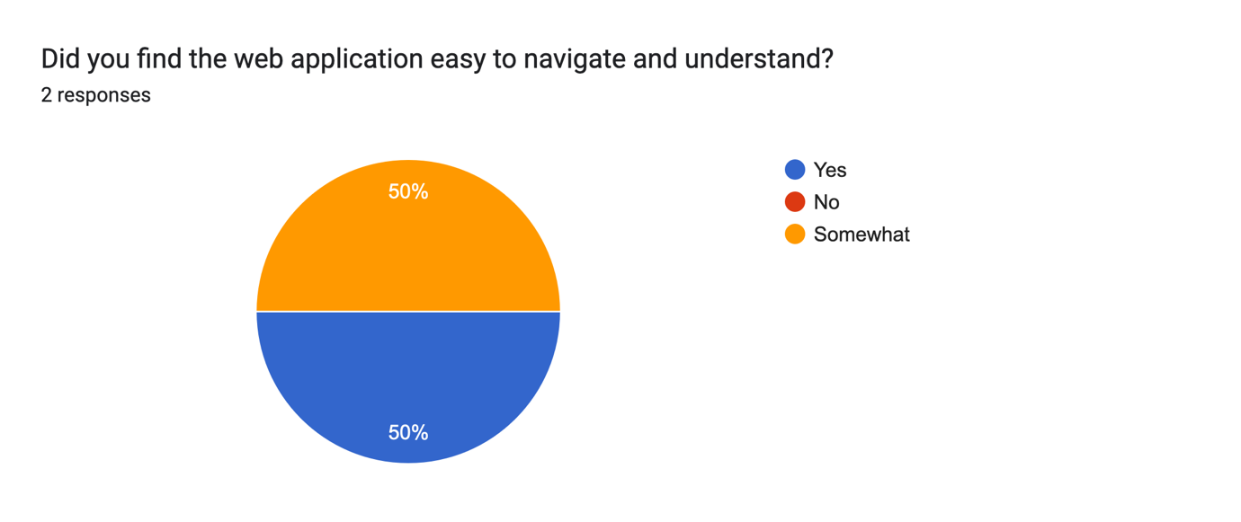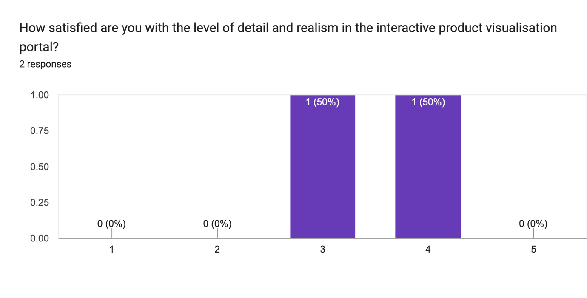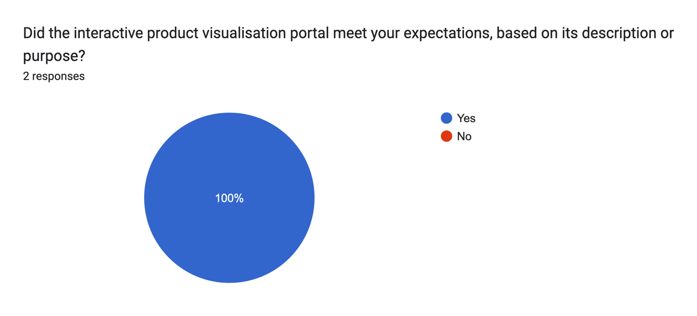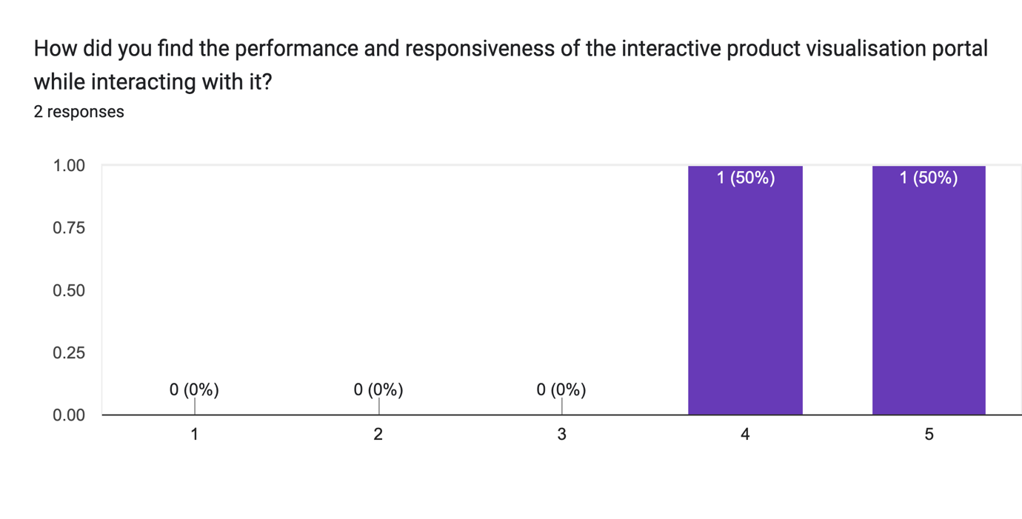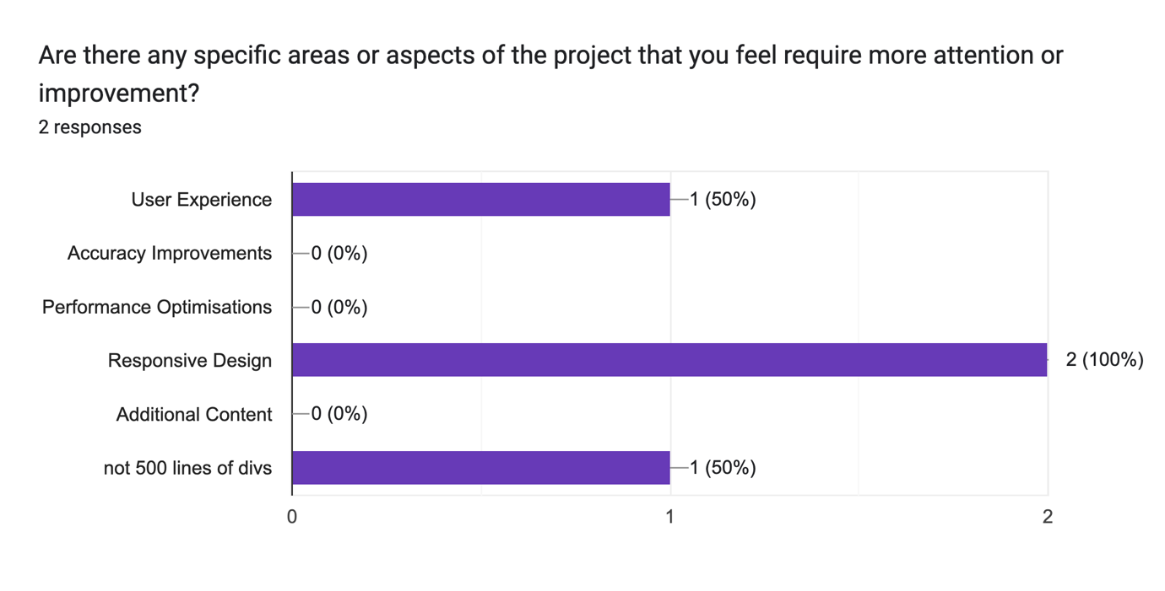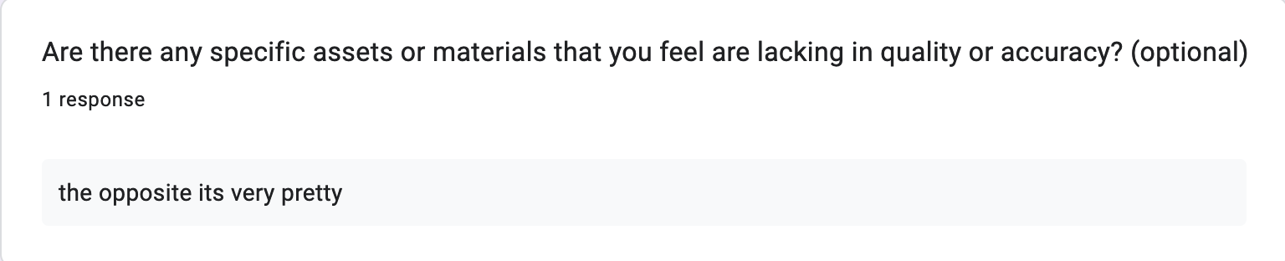

**Post-Production Questionnaire:**



